Topic | Bandwidth-dependent transformation of noise data from frequency into time domain and vice versa
Authors | Peter Bormann (formerly GeoForschungsZentrum Potsdam,  Telegrafenberg, D-14473 Potsdam, Germany), E-mail: pb65@gmx.net  Erhard Wielandt (formerly Institute of Geophysics, University of Stuttgart, D-70184 Stuttgart, Germany), E-mail: e.wielandt@t-online.de
Version | April 2001

1 Aim

The exercise aims at:
- deepening the understanding and developing manual skills in using the related equations presented in 4.1 of Chapter 4;
- application of the conversion program NOISECON (see PD 4.1);
- demonstrating that the various data presentations given in this Exercise and in Chapter 4 on signal and noise spectra or amplitudes in different kinematic units are in fact all compatible or – if not – that reasons for it can be given.

Fundamentals

The underlying fundamentals have been outlined in detail in the introduction to Chapter 4. In summary, the following should be remembered:

When a broadband signal is split up into narrower frequency bands with ideal band-pass filters, then
- the instantaneous amplitudes in the individual bands add up to the instantaneous amplitude of the broadband signal,
- the signal powers (or energies in case of transient signals) in the individual bands add up to the power (or energy) of the broadband signal,
- the rms amplitudes in the individual bands DO NOT add up to the rms amplitude of the broadband signal.

A specification of noise amplitudes without a definition of the bandwidth is meaningless!

Also: Signal energy is the time-integral of power. Accordingly, transient signals have a finite energy while stationary (noise) signals have an infinite energy but a finite and, in the time average, constant power. Transient signals and stationary signals must therefore be treated differently. The spectrum of a transient signal cannot be expressed in the same units as the spectrum of a stationary signal. Earthquake spectra and noise spectra can, therefore, not be represented in the same plot, unless the conversion between the units is explained. Also, band-pass filtered amplitudes in different spectral ranges are comparable only when having been filtered with the same relative bandwidth (RBW). Note that in signal analysis the "power" of a signal is understood to be the mean square of its instantaneous amplitude. Physical power is proportional but not identical to what is called "power" in signal analysis - for example, the electric power is W = U²/ R, not W = U^{2.}.

3 Data, relationships and programs

The exercises are based on data presented in Figs. 4.5 to 4.8 and the Figures 1 to 3 below.

Figure 1 Compilation of various noise amplitude and power spectral densities at various stations and according to the Brune and Oliver (1959) noise model as published by Fix (1972).

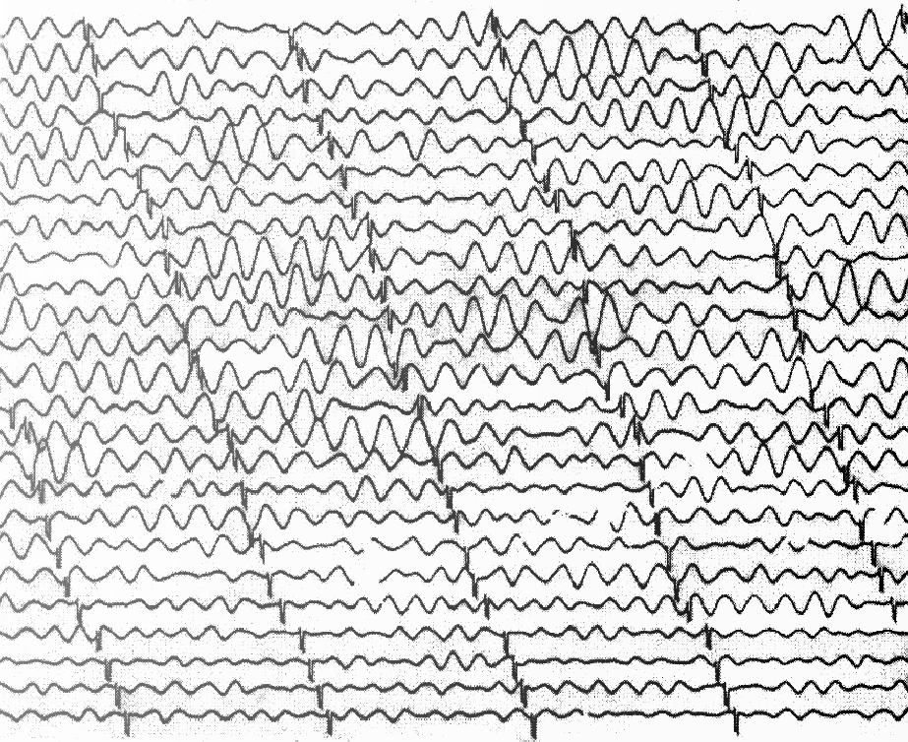

Figure 2 Cut-out section of a record of the WWSSN-LP seismograph of strong secondary ocean microseisms caused by a winter storm over the Atlantic ocean, reproduced at original scale (30 mm = 1 minute). The magnification at the dominant period is about 400 times.

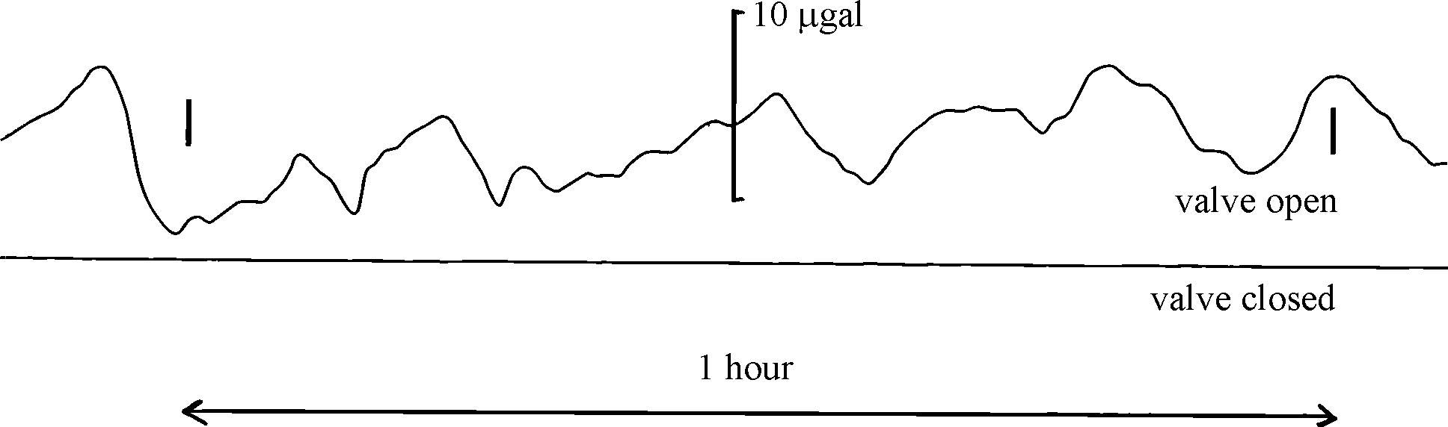

Figure 3 Output signal of an STS1 seismometer with the vacuum bell valve open (upper trace) and closed (lower trace), respectively. The noise in the top trace is caused by changes in barometric pressure.

For manual solutions use the respective relationships given in Eqs. (4.4) to (4.17) of Chapter 4 and a pocket calculator with the required basic functions. Alternatively, you may use the program NOISECON (see program description PD 4.1).

4 Tasks

Task 1: Determine the relative bandwidth (RBW) of an

a) 2-octave filter

b) 2/3-octave filter

c) 1/3-octave filter

d) 1/6-decade filter

by using Eq. (4.15) in Chapter 4 and

e) express the bandwidth of an 1/3-decade filter in terms of octaves

by using Eq. (4.17).

Task 2: Calculate for the noise maximum of the upper curve in Fig. 4.5 the corresponding RMS ground motion (velocity and displacement).

a) Estimate the velocity power maximum from Fig. 4.5 (Note the logarithmic scale!).

b) Give this value also in units of (m/s)²/Hz.

c) Estimate the frequency f_{o} related to this maximum.

d) Calculate the RMS-velocity amplitude a_{vRMS} by considering Eqs. (4.15) and (4.16) and
a relative bandwidth of 2/3 octaves.

e) Transform this RMS velocity amplitude determined under d) into the corresponding
RMS displacement amplitude a_{dRMS} considering Eq. (4.4).

Task 3: Transform the displacement power values of Fig. 4.6 at f = 1 Hz and f = 10 Hz in

a) units of m²/Hz,

b) acceleration power values with units (m/s²)²/Hz using Eq. (4.5),

c) the values determined under b) in units of dB referred to 1 (m/s²)²/Hz according to Eq.
4.6) and

d) compare the result with the respective values in Fig. 4.7 for the New Low Noise
Model (NLNM).

Task 4: Determine from Fig. 4.7 the respective ground acceleration power spectral density values of the NHNM in units of (nm/s²)²/Hz for

a) f = 1 Hz ,

b) f = 0.1 Hz .

using Eq. (4.6)

Task 5: Select any period between 0.01 and 10,000 sec (e.g., T = 100s) and confirm
that the presentations in Figs. 4.7 and 4.8 in Chapter 4 are equivalent when assuming a relative bandwidth of 1/6 decades as used in Fig. 4.8.

Task 6: Transform selected velocity PSD values given in the lower curve of Fig. 4.23 into acceleration PSD P_{a}[dB] = 10 log (P_{a} / 1 (m/s²)²/Hz) via Eq. (4.5) and compare them with the NLNM at

- 1.5 Hz and

- 10 Hz.

Task 7: Figure 1 has two parallel vertical scales one of which is obviously incorrect. Which one? Using the correct scale and the lowermost curve:

- compare the noise at 100 s and 1000 s period to the respective values given for the NLNM in Fig. 4.7

- discuss the difference.

Task 8: Assess the noise level of the microseism storm in Figure 2 with respect to the NLNM

- Determine the range of periods of the microseisms.

- Estimate the bandwidth of the microseisms, their center frequency f_{o} and RBW.

- Estimate the displacement a_{RMS} from the average peak amplitudes (which are about 1.25a_{RMS}). The magnification of the record is about 400 at f_{o.}

- Transform the displacement a_{RMS} into acceleration a_{RMS} and P_{a} [dB].

- Compare with Fig. 4.7 and discuss possible differences.

Taks 9: Compare the noise level for the acceleration records of an STS1 seismometer
shown in Figure 3 and compare it with the NLNM. Note that 1 gal = 10⁻² m/s².

- Estimate a_{RMS} from the average peak amplitudes in Figure 3, upper trace.

- Estimate the upper limit of a_{RMS} for the lower trace in Figure 3.

- Estimate the periods and bandwidth of the noise in Figure 3.

- Compare the a_{RMS} for the upper and the lower trace with the NLNM presentation in Fig. 4.8.

- Discuss the differences.

5 Solutions

Note: The errors in eye readings of the required parameters from the diagrams may be 10 to 30 %. Therefore, it is acceptable if your solutions differ from the ones given below in the same order or by about 1 to 3 dB in power. In case of larger deviations check your readings and calculations. Also: all power values given below in dB relate to the respective units in Fig. 4.7.

Task 1: a) 1.5

b) 0.466

c) 0.231

d) 0.386

e) 1.1 octaves

Task 2: a) 7×10⁻⁸ (cm/s)²/Hz

b) 7×10⁻¹² (m/s)²/Hz

c) 0.16 Hz

d) a_{vRMS}≈ 7×10⁻⁷ m/s

e) a_{dRMS}≈ 7×10⁻⁷ m

Task 3: a) 2×10⁻¹⁸ m²/Hz at 1 Hz and 1.5×10⁻²² m²/Hz at 10 Hz

b) 3.12× 10⁻¹⁵ (m/s²)²/Hz at 1 HZ and 2.3× 10⁻¹⁵ (m/s²)²/Hz at 10 Hz

c) - 145 dB for 1 Hz and -146 dB for 10 Hz

d) The noise power at this site is for the considered frequencies about 20 dB
higher than for the NLNM.

Task 4: a) and b) ≈ -117 dB, i.e., ≈ 2×10⁶ (nm/s²)²/Hz ;

Task 5: For T = 100 s we get from Fig. 4.7 P_{a} [dB] = -185 dB. With RBW = 0.3861 for 1/6 octave bandwidth and f = 0.01 Hz we calculate with Eq. (4.16) a_{RMS}² = 1.1 × 10⁻²¹ (m/s²)² which is about –210 dB, in agreement with Fig. 4.8.

Task 6: a) P_{a} ≈ -153 db, 16 dB above the NLNM

b) P_{a} ≈ -153 db, 15 dB above the NLNM

Task 7: The amplitude-density scale in Figure 1 is inapplicable to noise and cannot be related to the power-density scale, which is correct.

a) at 0.01 Hz P_{d} = 2×10⁻¹⁴ corresponds to P_{d} = -137 dB

at 0.001 Hz P_{d} = 2×10⁻⁶ corresponds to P_{d} = -57 dB

b) The NLNM gives, according to Fig. 4.7, P_{d} ≈ -137 dB for T = 100 s (see also Tab. 4.2) and P_{d} ≈ -90 dB for T = 1000 s, i.e., the agreement with the Fix (1972 ) noise spectra is perfect for a) but for b) the noise level of NLNM at T = 1000 s is –33 dB lower.

Task 8: a) The periods of the microseisms in Figure 2 vary between T = 7 s (for the
smaller amplitudes) and T = 10 s (for the largest amplitudes).

b) From this upper and lower period follows with Eq. (4.13) n ≈ 0.5 octaves or m ≈ 1/6 decade, a center frequency of f_{o} ≈ 0.119 Hz (T_{o} ≈ 8.4 s) and an RBW of ≈ 0.36

c) Maximum double trace amplitudes of the microseisms range between about 6 and 3 mm, average about 4.5 mm, corresponding to a “true” average peak ground amplitude of about 5.6 × 10⁻⁶ m and thus to a displacement a_{RMS} ≈ 4.5 × 10⁻⁶ m.

d) The acceleration a_{RMS} ≈ 2.5 × 10⁻⁶ m for f_{o} ≈ 0.119 Hz and P_{a} ≈ -98 dB.

e) P_{a} ≈ -98 dB for this microseismic storm is close to the power at the NHNM peak around T = 5 s (-96.5 dB) but about 15 dB higher than the NHNM values at T ≈ 8 s. Thus, the record corresponds to a really strong microseism storm.

Task 9: a) From Figure 3, upper trace, the estimated average peak amplitude is about
2.5 μgal and thus a_{RMS} about 2 × 10⁻⁸ m/s².

b) The related upper limit of about 1/100th of a), i.e., a_{RMS} < 2 × 10⁻¹⁰ m/s².

c) The periods of the noise in Figure 3 range between roughly 180 s and 750 s.
This corresponds to a bandwidth of about 2 octaves or an RBW of 1.5.

d) The a_{RMS} for the open valve corresponds to – 154 dB, that for the closed
valve to < –194 dB.

e) Taking into account that Fig. 4.8 was calculated for 1/6 decade bandwidth
only but the bandwidth of the considered noise signals being about 3 times larger we have to assume an about 5 dB higher noise level in Fig. 4.8. Therefore, for periods < 30 s the barometric pressure noise is surely well below the NLNM when the sensor operates in a vacuum. A higher resolution of the record with the vacuum bell valve closed would be required in order to determine the noise level distance to the NLNM for T > 30 s.

