Title | Seismometer calibration with program CALEX
Author | Erhard Wielandt (formerly Institute of Geophysics, University of Stuttgart, D - 70184 Stuttgart); E-mail: e.wielandt@t-online.de
Version | October 2001; minor update May 2010

- Software and Data

It is recommended to download the latest versions of the CALEX and WINPLOT software from www.software-for-seismometry.de .

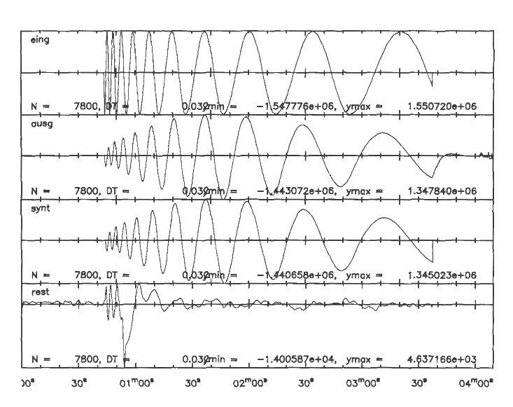
Two pairs of input ("eing") and output ("ausg") signals are available. They are shown in Figures 1 and 2; one set is from a broadband seismometer and the other from a short-period geophone. File names may differ depending on the version.
Figure 1 The input signal into the calibration coil (eing) is a "sweep", a sine-wave whose frequency is automatically tuned from about 2 s to 50 s. It is used for calibration of a 20-sec STS1 seismometer. The second and third traces show the output (ausg) signal and the best fitting synthetics (synt), respectively. The lowermost trace is the residual signal (ausg - synt = rest).

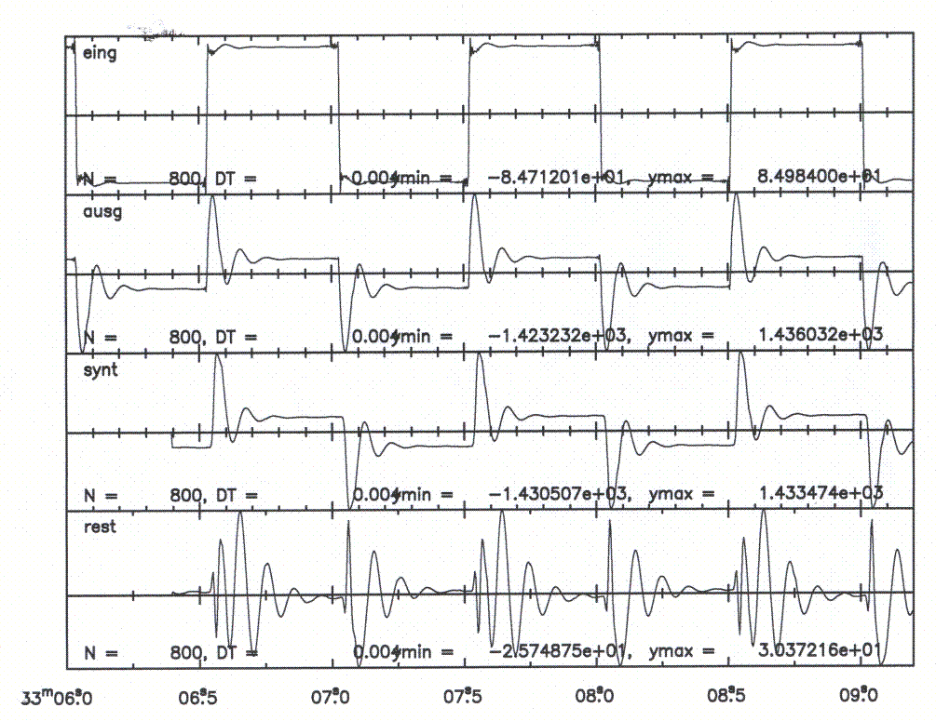
Figure 2 The input signal is a square wave. It is used for calibration of an undamped 10 Hz geophone in a half-bridge. Note that the input signal appears in the output by coupling through the coil resistance. This would not be the case for a seismic input signal and therefore must not be interpreted as part of the transfer function.

2 Tasks

1 - Plot the signals on the screen and get an idea of the time scale, of the free period and damping of the sensor, and of the type of response (high-pass, band-pass, low-pass?). You will also need an estimate of polarity and gain between input and output. Compare what you see in the plot to your knowledge of the general properties of seismometer transfer functions.

2 - Set up the calex.par file for each experiment, as specified in the program description. A sample file is listed there.

3 - Run CALEX to determine the exact instrumental constants. Inspect the residual signal and determine its magnitude relative to the output signal (the misfit). Is the misfit caused by improper parametrization of the transfer function, by seismic or environmental noise, or by nonlinear behavior of the sensor? In the latter case, can you guess what the problem might be?

4 - Run CALEX again with deliberately offset start parameters, to see if their choice (within a reasonable range) is critical. You may also restrict the analysis to a smaller time window within the record and see if you get different results.

3 Solutions

Please read the Program Description for the CALEX and WINPLOT routines before continuing. If you use an older program version, it may be necessary to copy ‘eing1’ onto ‘eing’ (input signal) and ‘ausg1’ onto ‘ausg’ (output signal).

Tasks 1 and 2, first signal: On a Windows PC, you may use the ‘winplot’ routine for plotting the seismograms. To display the two signals, you have to prepare a small parameter file named winplot.par containing parameters and file names (as specified in the program description of winplot). Under LINUX, use your own plotting routine.

An electromagnetic seismometer, or a broadband-velocity sensor, acts as a band-pass filter for ground accelerations or calibration signals. It gives a maximum response when the signal period equals the free period of the system. By inspecting of the ausg signal, you will recognize that this is in fact a band-pass response, and the free period is around 20 s. The damping is more difficult to estimate, but since the resonance is not sharp, damping must be considerable. Knowing that 1/sqrt(2) or about 0.7 is a standard value for seismometers, you should start the inversion with this value. The gain between eing and ausg is around unity and the signals have the same phase at the resonance, so the gain parameter in calex.par may be set to 1.

Second signal: copy the data files as above if necessary, and inspect the ‘ausg’ file. Use the “sub” parameter to remove the resistive component of the output signal (see program description).The free period is obviously around 0.1 s. The damping may be estimated using formula 5.32 (section 5.6.5) of the NMSOP; it is similar to the previous case. The gain between eing and ausg is again near unity and positive.

Task 3, first signal: you should approximately get 19.7 s for the free period, 0.72 for the damping, 1.36 for the gain, 10 ms for the delay, and a rms residual below 0.003. Change the second parameter in ‘winplot.par’ to 4 and add the file names ‘synt’ and ‘rest’. (New versions of CALEX do this automatically.) Note the transient disturbance in the ‘rest’ signal at the end of the first minute, which was caused by a person entering the room. Its effect on the result is quite small.

Second signal: the period is 0.102 s, the damping 0.65, the gain is 1.17, and about 48% of the input signal are present in the output signal. The rms residual is again below 0.003. Note the asymmetry in the residual between upgoing and downgoing steps. What you see is mass-position dependent, nonlinear behaviour of the geophone; this is not a bad geophone, but it’s no force-balance sensor. You may also notice the small wiggles before and after each step of the input and output signals. (Zoom into a time window with ‘seipl02’ for better resolution.) The wiggles are not present in the analog signals but are generated by the decimation filters of the digital recorder. Since these filters affect both signals, they don’t appear in the transfer function.

Task 4: the results should be nearly independent of the start parameters and of the data window as long as the essential information is preserved in the window.

