Title | Determination of seismograph response from poles and zeros
Author | Erhard Wielandt (formerly Institute of Geophysics, University of Stuttgart, D - 70184 Stuttgart); E-mail: e.wielandt@t-online.de
Version | October 2001

1 Aim

The complex transfer function (or the related complex frequency response) of the analog part of a seismograph is a rational function of frequency. Such functions can be specified by corner frequencies and damping constants, by polynomial coefficients, or by their poles and zeros. The latter method is chosen in the IRIS SEED data volumes. For each data channel of each station, the data header contains a list of poles and zeros of the transfer function together with some auxiliary information. IRIS supplies a software library 'evalresp' for extracting and interpreting these parameters. The exercise aims at making you familiar with interpreting poles and zeros in terms of the amplitude response versus frequency.

2 Task

Interpret one or more of the annexed SEED headers with respect to the analog part of the seismograph. Sketch the amplitude response for one of the stations as a Bode-diagram on double logarithmic paper. (The digital part is usually of minor interest since it is supposed to have a flat amplitude response and zero phase delay.) Does the header describe a very broadband, broadband or narrowband system? Note that the answer does not only depend on the mathematical form of the response but also on the definition of the input signal - displacement, velocity or acceleration. A broadband seismograph is supposed to have a broadband response to velocity but a broadband accelerometer has a broadband response to acceleration. Be careful with the units - some headers refer to Hertz rather than radians/sec. Check also whether the poles and zeros refer to the Laplace transform or Fourier transform. Can you guess which type of sensor is used? Are the constants nominal or were they determined from an individual calibration?

A little computer program POL_ZERO in BASIC will be made available to you to do the numerical conversions and to plot the amplitude response (see PD_5.8). Use this program to analyze some more of the SEED headers. The stations are:

KIP (Kipapa, Hawaii)
KONO (Kongsberg, Norway)
KMI (Kunming, China)
PFO (Pinion Flat Observatory, California)
XAN (Xi'an, China)

3 Annex

SEED headers for stations KIP, KONO, KMI, PFO and XAN

KIP
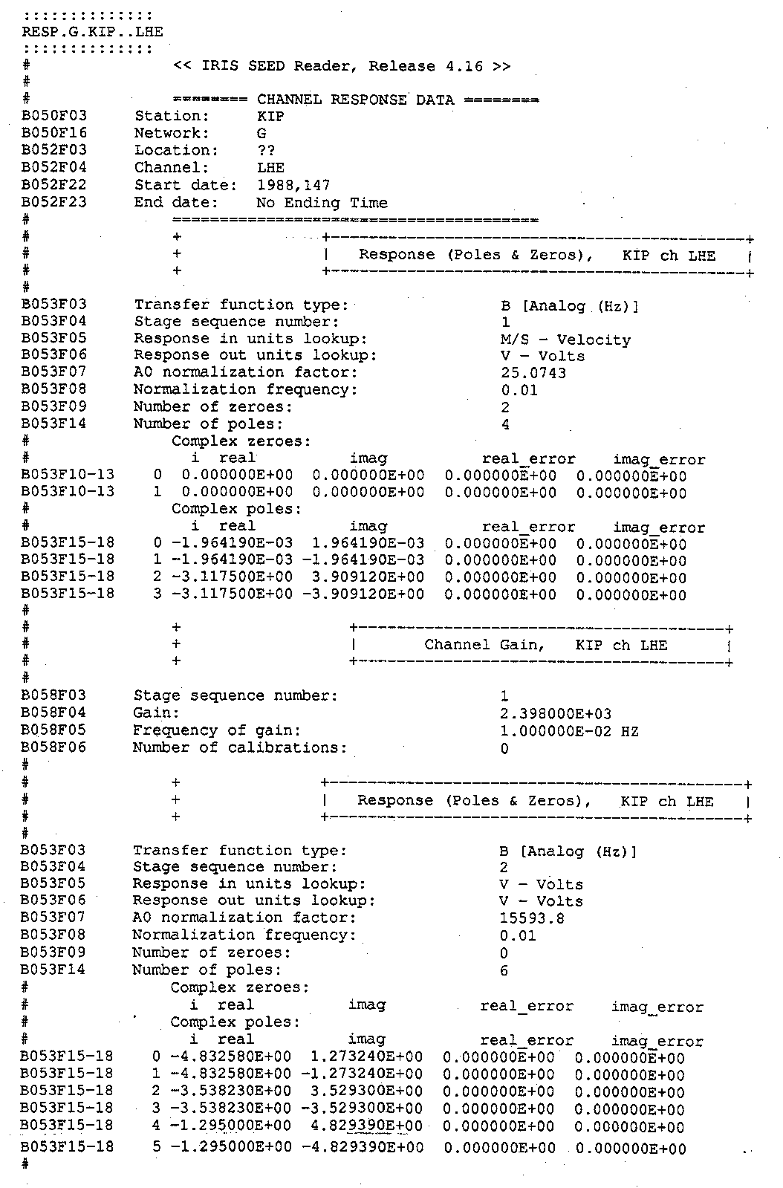

Kono
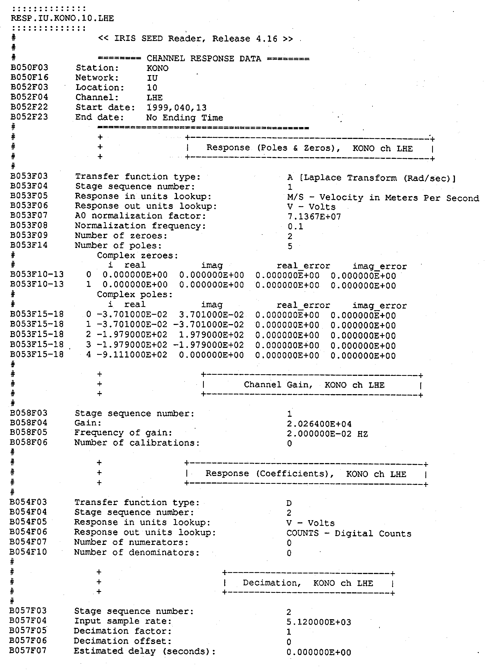

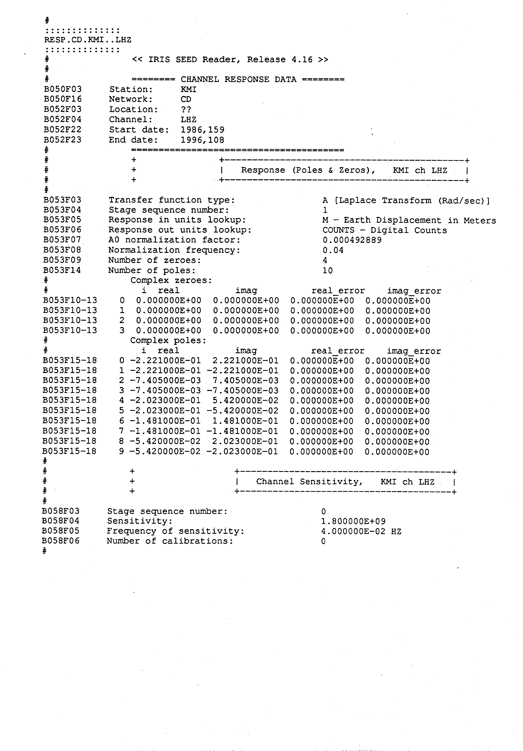
KMI

PFO
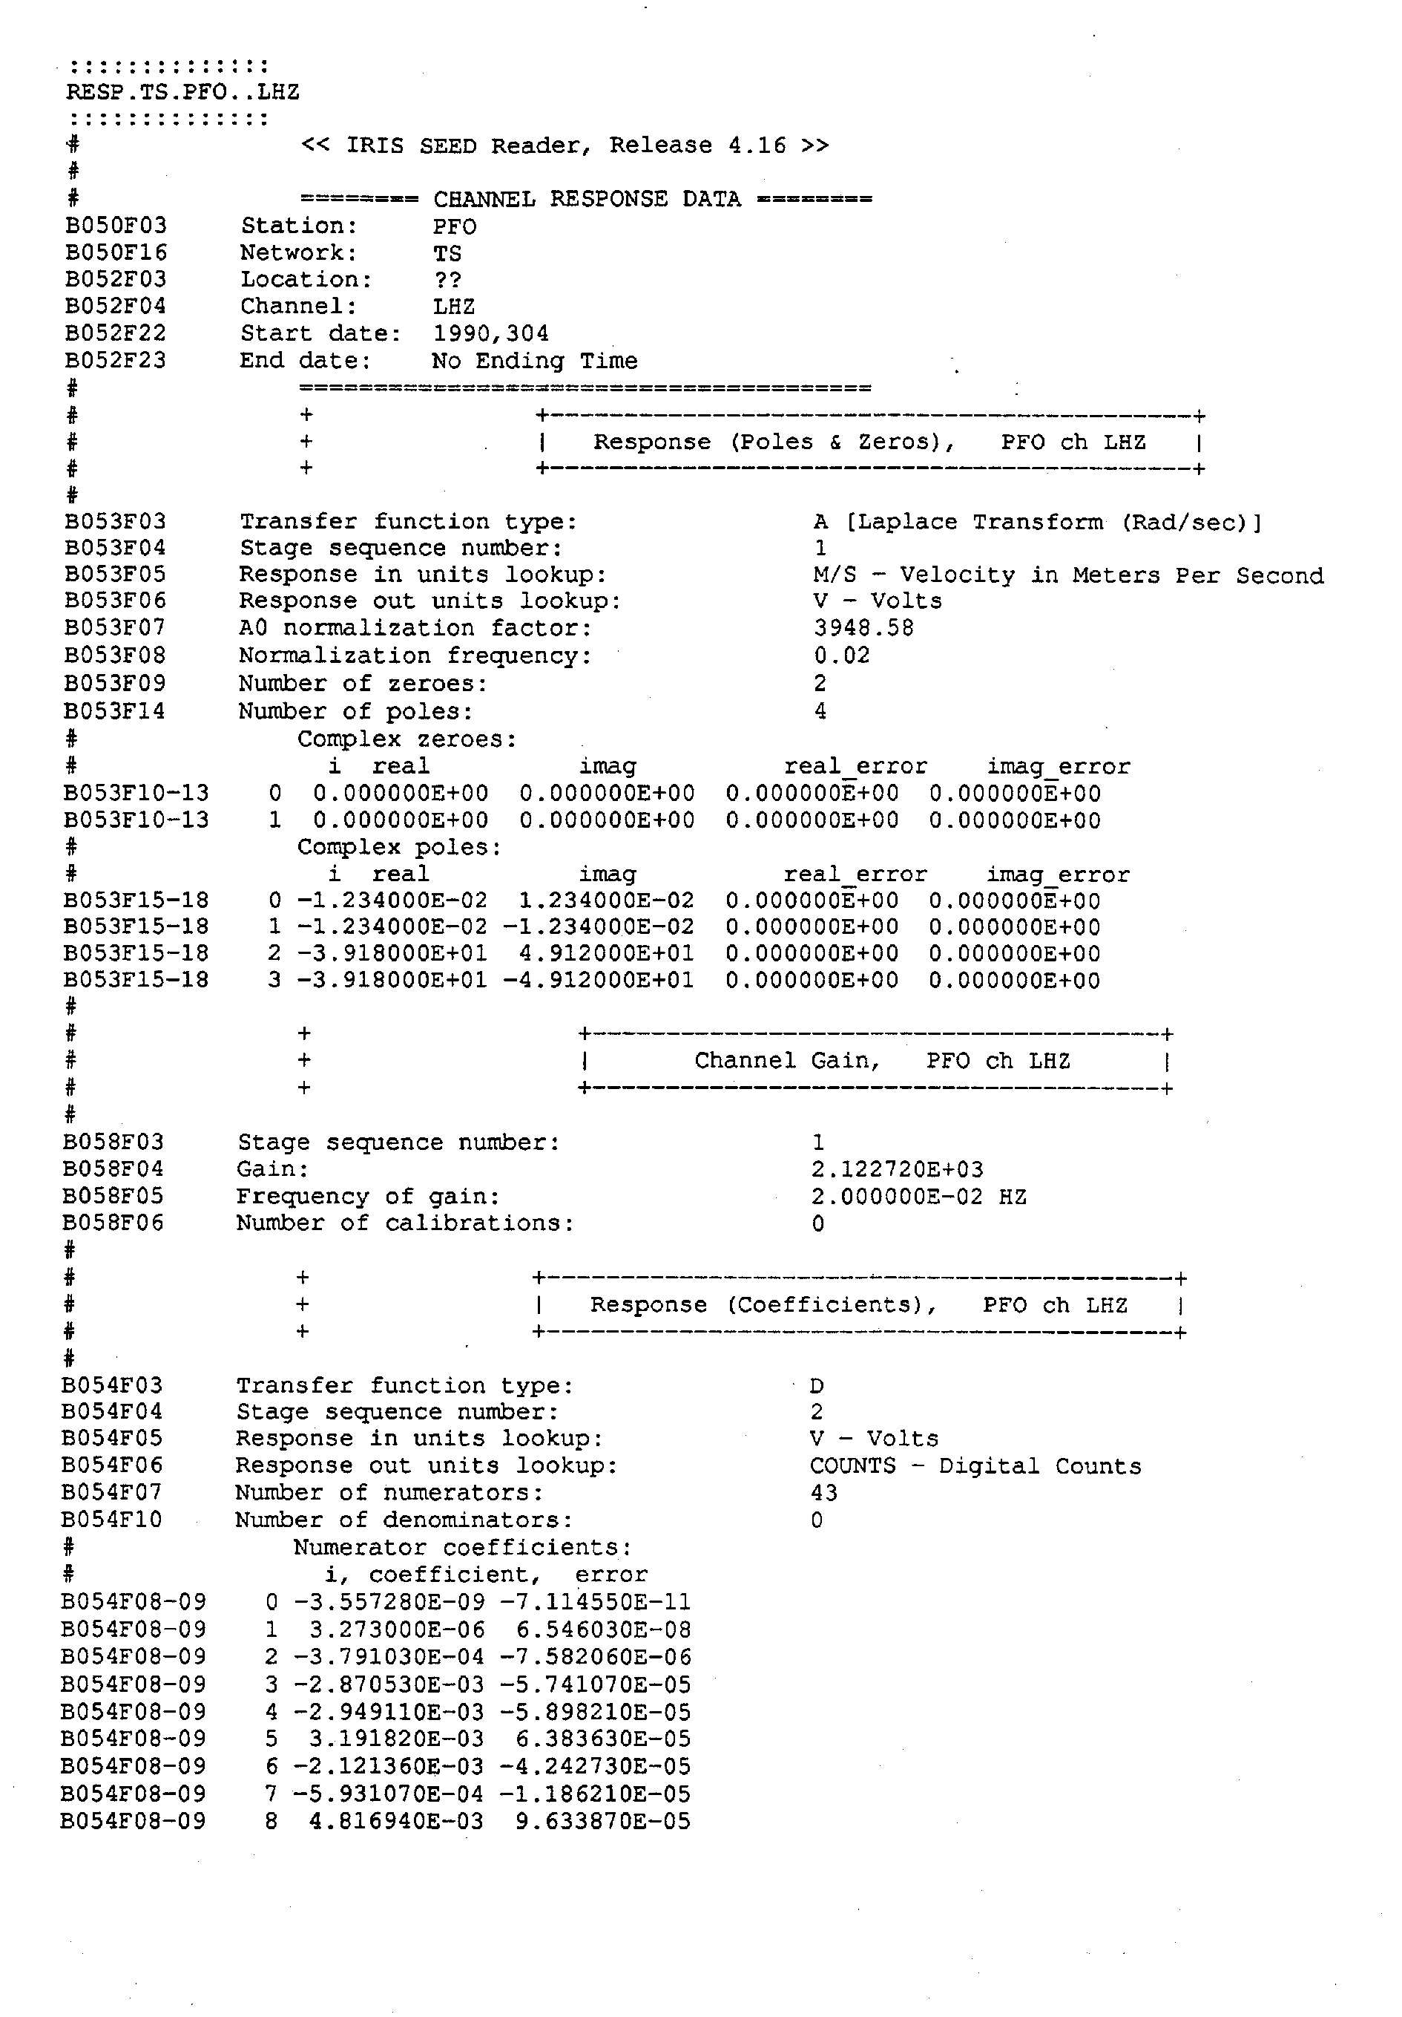

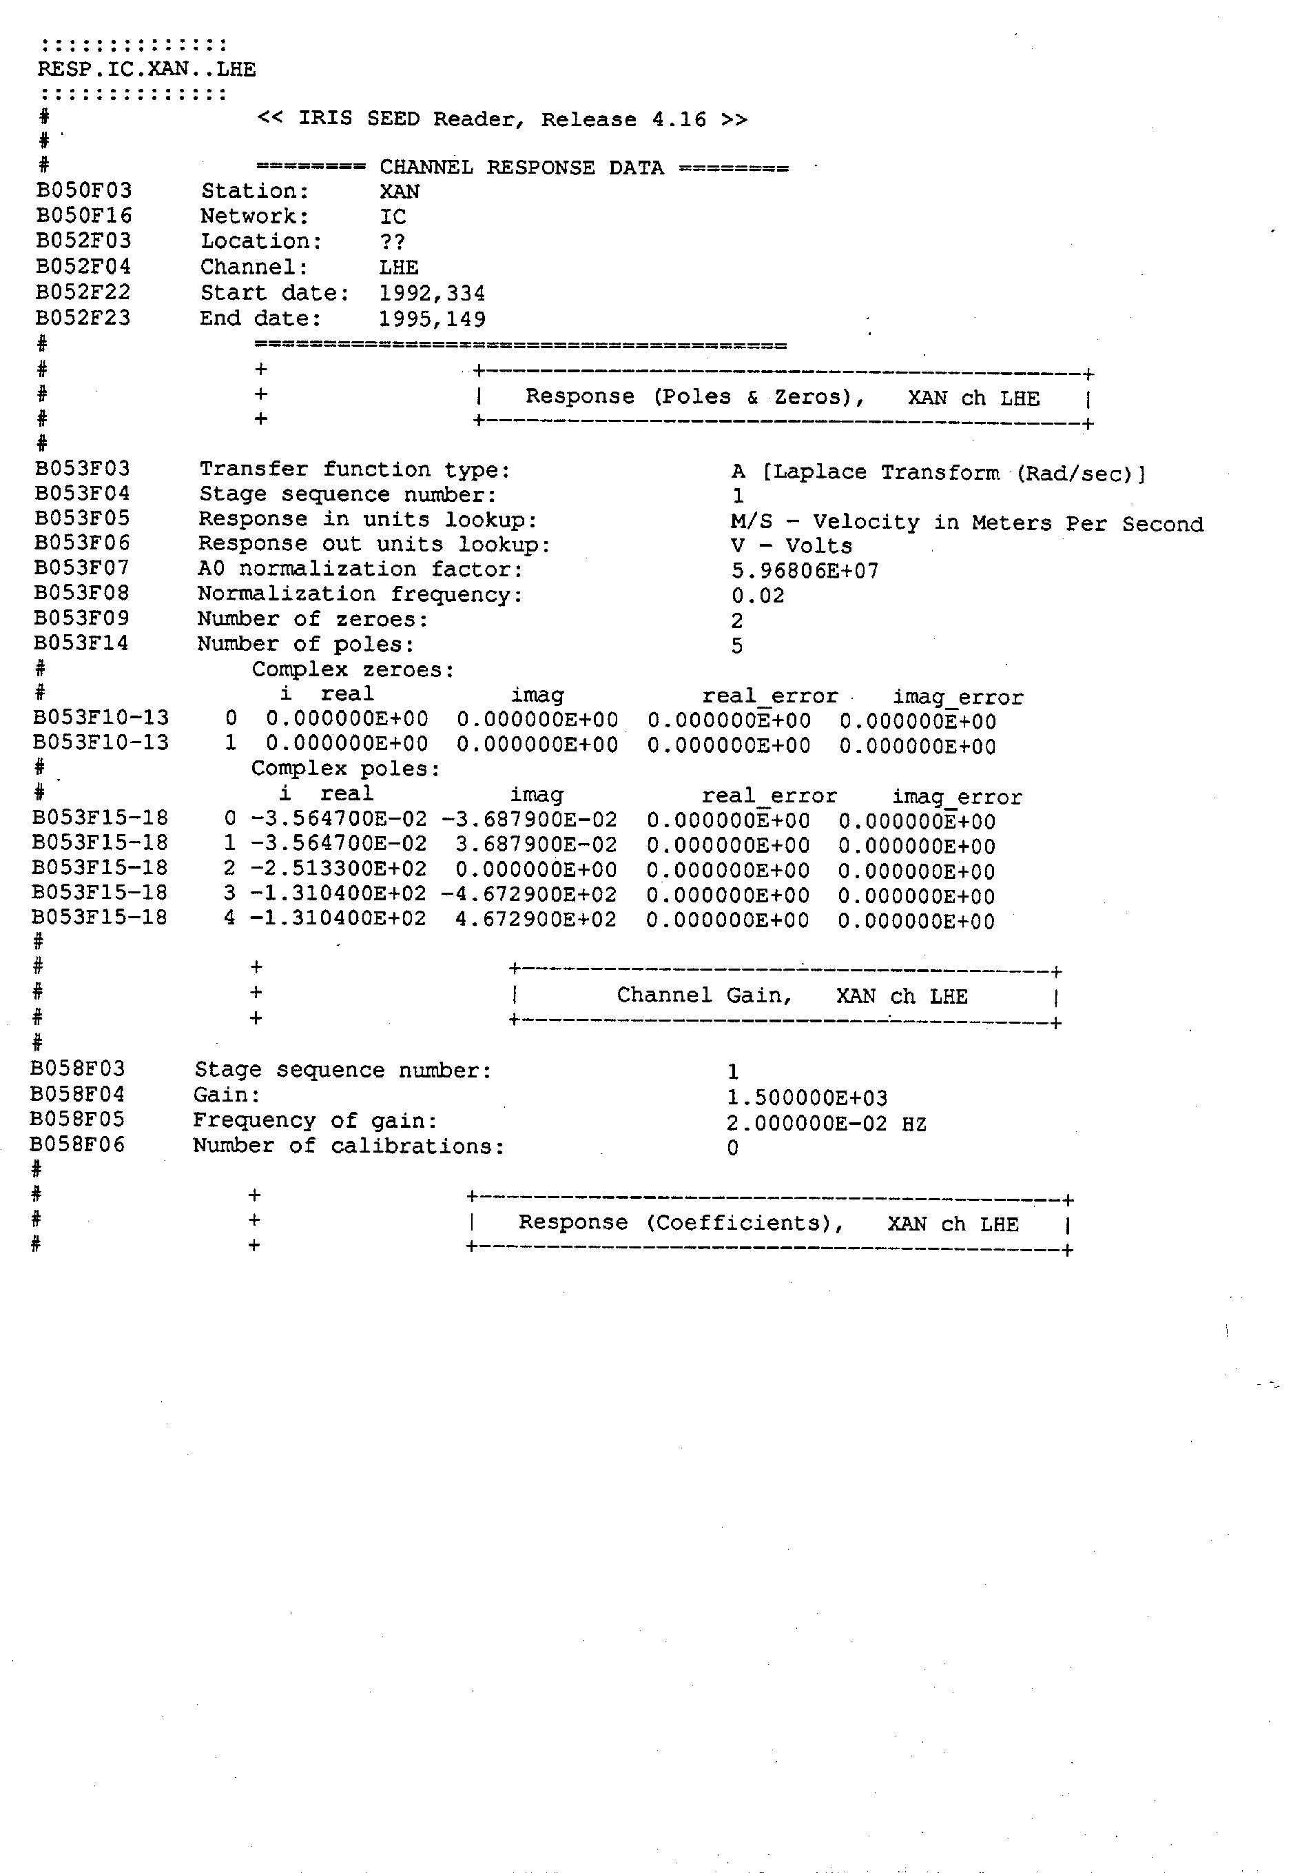
XAN

3 Solutions

KIP velocity very broadband, lower corner 360 s, upper corner 0.2 s
Obviously an older STS1-VBB seismometer. No extra filters.
Nominal parameters.

KONO velocity broadband, lower corner 120 s, upper corner 44.5 Hz
Must be an STS2 or a CMG3-T. Nominal parameters. Additional
low-pass Filter at 145 Hz.

KMI narrowband LP as a displacement sensor, but better characterized as
a long-period acceleration sensor. Response is flat to acceleration
from 30 s to 600 s. The sensor must be an old STS1 (20 s). A 6th-order
Butterworth low-pass filter limits the bandwidth at 30 s; this would
today be done with digital filters in the recorder. Parameters are nominal.

PFO velocity very broadband, lower corner 360 s, upper corner 0.1 s.
A modern STS1-VBB. No extra filters. Nominal parameters.

XAN velocity broadband, lower corner 120 s, upper corner 44 Hz.
Probably an STS2 or a CMG3-T seismometer. Additional low-pass
filter at 77 Hz. Parameters were probably measured.

