Worksheet 5.7: The response of a WWSSN-LP seismograph

The long-period seismograph of the now obsolete WWSSN (Worldwide Standardized Seismograph Network) consisted of a long-period electrodynamic seismometer normally tuned to a free period of 15 sec, and a long-period mirror-galvanometer with a free period around 90 sec. (In order to avoid confusion with the frequency variable s = jω of the Laplace transformation, we use the non-standard abbreviation „sec“ for seconds in the present subsection.) The WWSSN seismograms were recorded on photographic paper rotating on a drum. The simple design of this system gives us an opportunity to write down several equivalent forms of the transfer function explicitly. Since input and output signals can be measured as displacements, it is natural to describe the system by its displacement response. The absolute value of this response is the frequency-dependent magnification. We assume the numerical damping to be 0.6 for the seismometer and 0.9 for the galvanometer. For simplicity, we ignore the small difference between the free periods and damping constants of the physical subunits and those that appear in the transfer function of the coupled system. We further assume that the effective generator constant of the electromagnetic velocity transducer in the seismometer is 200 V per m/sec, and the photographic trace is deflected by 0.3935 mm per microvolt.

Tasks:
- Write down the transfer function for displacement as a function of the Laplace variable s, using symbolic algebra (that is, representing free period and damping by mathematical symbols, not their numerical values)
- Write down the formula for the “magnification curve” (amplitude response as a function of the angular frequency), using symbolic algebra
- Represent the magnification curve as a “Bode plot”, that is, approximate it by asymptotic straight lines in a double-logarithmic plot
- Determine the poles and zeros of the transfer function in symbolic algebra, and evaluate them numerically
- Sketch the position of poles and zeros in the complex s plane
- Write down the transfer function as the ratio of two polynomials with numerical coefficients

Solution:
As shown in section 5.2.8, Eq. 5.23, the transfer function of an electromagnetic seismometer (input: displacement, output: voltage) is

$H_{s}(s)={{\text{Es}}^{3}}/(s^{2}+2{sω}_{s}h_{s}+ω_{s}^{2})$

where $ω_{s}=2π/{T_{s}}$ is the angular eigenfrequency and $h_{s}$ the numerical damping. (see EX 5.2 for a practical determination of these parameters.) The factor E is the generator constant of the electromagnetic transducer, for which we assume a value of 200 Vsec/m.

The galvanometer is a second-order low-pass filter and has the transfer function

$H_{g}(s)={{\text{γω}}_{g}^{2}}/(s^{2}+2{sω}_{g}h_{g}+ω_{g}^{2})$

Here γ is the responsivity (in meters per volt) of the galvanometer with the given coupling network and optical path. We use a value of 393.5 m/V, which gives the desired overall magnification. The overall transfer function H_{d} of the seismograph is obtained in our simplified treatment as the product of the factors given in Eqs. and :

$H_{d}(s)=\frac{{\text{Cs}}^{3}}{(s²+2{sω}_{s}h_{s}+ω_{s}^{2})(s^{2}+2{sω}_{g}h_{g}+ω_{g}^{2})}$

The numerical values of the constants are C = Eγω_{g}² = 383.6/sec, 2ω_{s}h_{s} = 0.5027/sec,
ω_{s}² = 0.1755/sec², 2ω_{g} h_{g} =0.1257/sec, and ω_{g}² = 0.00487/sec².

As the input and output signals are displacements, the absolute value |H_{d}(s)| of the transfer function is simply the frequency-dependent magnification of the seismograph. The gain factor C has the physical dimension sec⁻¹, so H_{d} (s) is in fact a dimensionless quantity. C itself is however not the magnification of the seismograph. To obtain the magnification at the angular frequency ω, we have to evaluate M(ω) = |H_{d} ( jω)|:

$M(ω)=\frac{Cω ^{3}}{\sqrt{(ω_{s}^{2}−ω^{2})^{2}+4ω^{2}ω_{s}^{2}h_{s}^{2}}\sqrt{(ω_{g}^{2}−ω^{2})^{2}+4ω^{2}ω_{g}^{ 2}h_{g}^{2}}}$

Eq. is a factorized form of the transfer function in which we still recognize the sub-units of the system. We may of course insert the numerical constants and expand the denominator into a fourth-order polynomial

$H_{d}(s)=\text{383}\text{.}6{s^{3}}/(s^{4}+0\text{.}\text{6283}s^{3}+0\text{.}\text{2435}s^{2}+0\text{.}\text{0245}s+0\text{.}\text{000855})$

but the only advantage of this form would be its shortness.

The poles and zeros of the transfer function are most easily determined from Eq. . We read immediately that a triple zero is present at s = 0. Each factor $s^{2}+2{sω}_{0}h+ω_{0}^{2}$ in the denominator has the zeros
$s_{0}=ω_{0}(−h±j\sqrt{1−h^{2}})$ for h <1
$s_{0}=ω_{0}(−h±\sqrt{h^{2}−1})$ for h $³$1
so the poles of H_{d} (s) in the complex s plane are (Fig. 1):

$s_{1}=ω_{s}(−h_{s}+j\sqrt{1−h_{s}^{2}})$ = -0.2513 + 0.3351j [sec${}^{−1}$]
$s_{2}=ω_{s}(−h_{s}−j\sqrt{1−h_{s}^{2}})$ = -0.2513 - 0.3351j [sec${}^{−1}$]
$s_{3}=ω_{g}(−h_{g}+j\sqrt{1−h_{g}^{2}})$ = -0.0628 + 0.0304j [sec${}^{−1}$]
$s_{4}=ω_{g}(−h_{g}−j\sqrt{1−h_{g}^{2}})$ = -0.0628 - 0.0304j [sec${}^{−1}$]

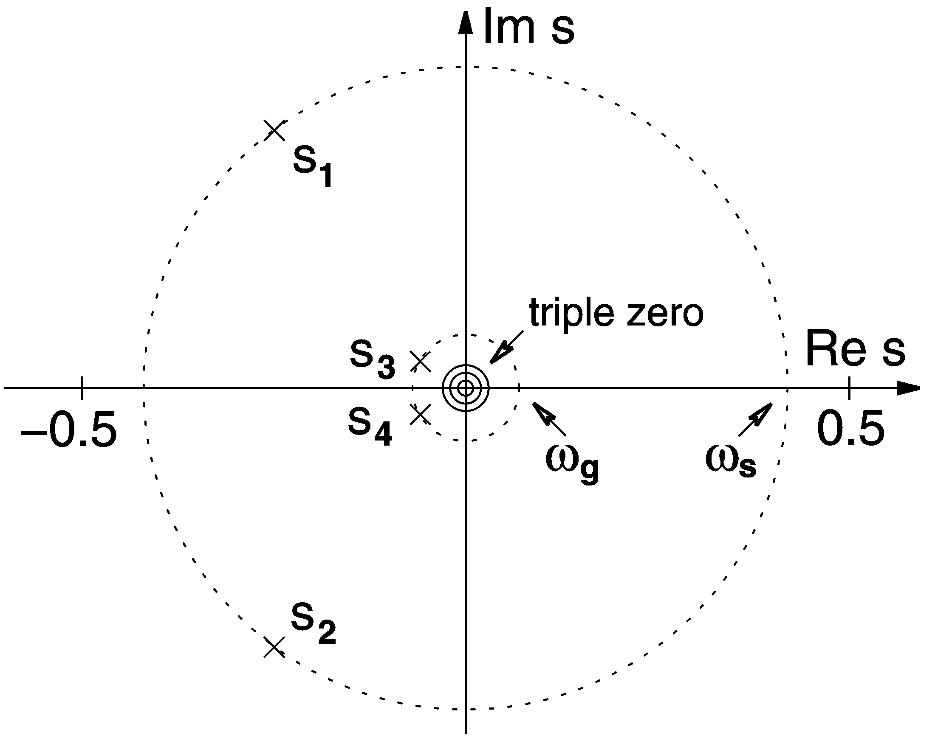

- Position of the poles of the WWSSN-LP system in the complex s plane.

In order to reconstruct H_{d}(s) from its poles and zeros and the gain factor, we write

$H_{d}(s)=\frac{{\text{Cs}}^{3}}{(s−s_{1})(s−s_{2})(s−s_{3})(s−s_{4})}$.

It is now convenient to pairwise expand the factors of the denominator into second-order polynomials:

$H_{d}(s)=\frac{{\text{Cs}}^{3}}{(s^{2}−s(s_{1}+s_{2})+s_{1}s_{2})(s^{2}−s(s_{3}+s_{4})+s_{3}s_{4})}$.

This makes all coefficients real because $s_{2}=s_{1}^{}$ and $s_{4}=s_{3}^{}$. Since $s_{1}+s_{2}=−2ω_{s}h_{s}$, $s_{1}s_{2}=ω_{s}^{2}$, $s_{3}+s_{4}=−2ω_{g}h_{g}$, and $s_{3}s_{4}=ω_{g}^{2}$, Eq. is in fact the same as Eq. . We may of course also reconstruct H_{d} (s) from the numerical values of the poles and zeros. Dropping the physical units, we obtain

$H_{d}(s)=\frac{\text{383}\text{.}6s^{3}}{(s^{2}+0\text{.}\text{5027}s+0\text{.}\text{1755})(s^{2}+0\text{.}\text{1257}s+0\text{.}\text{00487})}$

in agreement with Eq. .

Fig. 2 shows the corresponding amplitude response of the WWSSN seismograph as a function of frequency. The maximum magnification is 750 near a period of 15 sec. The slopes of the asymptotes are at each frequency determined by the dominant powers of s in the numerator and denominator of the transfer function. Generally, the low-frequency asymptote has the slope m (the number of zeros, here = 3) and the high-frequency asymptote has the slope m-n (where n is the number of poles, here = 4). What happens in between depends on the position of the poles in the complex s plane. Generally, a pair of poles s₁, s₂ corresponds to a second-order corner of the amplitude response with $ω_{0}^{2}=s_{1} s_{2}$ and $2ω_{0}h=−s_{1}−s_{2}$. A single pole at s₀ is associated with a first-order corner with $ω_{0}=s_{0}$. The poles and zeros however do not indicate whether the respective subsystem is a low-pass, high-pass, or band-pass filter. This does not matter; the corners bend the amplitude response downward in each case. In the WWSSN-LP system, the low-frequency corner at 90 sec corresponding to the pole pair s₁, s₂ reduces the slope of the amplitude response from 3 to 1, and the corner at 15 sec corresponding to the pole pair s₃, s₄ reduces it further from 1 to -1.

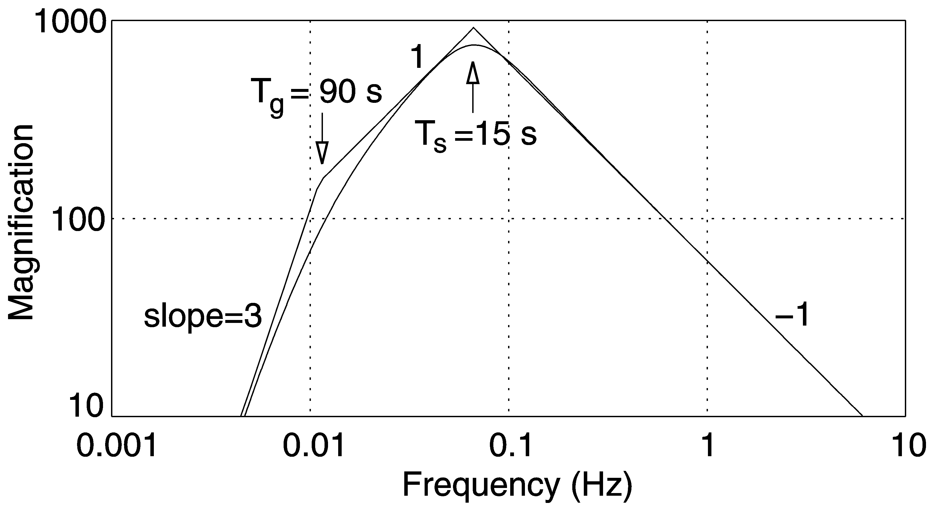

- Amplitude response (magnification curve) of the WWSSN-LP system with asymptotes (Bode plot, see Worksheet WS_5.1 and Exercise EX_5.2 of the NMSOP).

Looking at the transfer function H_{s} (Eq. ) of the electromagnetic seismometer alone, we see that the low-frequency asymptote has the slope 3 because of the triple zero in the numerator. The pole pair s₁, s₂ corresponds to a second-order corner in the amplitude response at $ω_{s}$ which reduces the slope to 1. The resulting response is shown in a normalized form in the upper right panel of Fig. 5.3. As stated in section 5.2.6 under point 3, this case of n<m can only be an approximation in a limited bandwidth. In modern seismograph systems, the upper limit of the bandwidth is usually set by an analog or digital cut-off (anti-alias) filter.

Section 5.2.8 shows that the classification of a subsystem as a high-pass, band-pass or low-pass filter may be a matter of definition rather than hardware; it depends on the type of ground motion (displacement, velocity, or acceleration) to which it relates. We also notice that interchanging ω_{s,} h_{s} with ω_{g}, h_{g} will change the gain factor C in the numerator of Eq. from Eγω_{g}² to Eγω_{s}² and thus the gain, but will leave the denominator and therefore the shape of the response unchanged. While the transfer function is insensitive to arbitrary factorization, the hardware may be quite sensitive, and certain engineering rules must be observed when a given transfer function is realized in hardware. For example, it would have been difficult to realize a WWSSN seismograph with a 15 sec galvanometer and a 90 sec seismometer; the restoring force of a Lacoste-type suspension cannot be made small enough without becoming unstable.

