Design Considerations for Broadband Seismometers

Erhard Wielandt, Institute of Geophysics, Stuttgart University
e.wielandt@t-online.de

Basic concepts

Seismometers are supposed to convert “ground motion” into an electric output signal. Two basic types exist: inertial seismometers measuring ground motion against an elastically suspended seismic mass, which serves as an inertial reference; and strain-meters measuring the motion of one point of the ground relative to another. Inertial seismometers basically respond to ground acceleration although their electric output signal may represent ground velocity or ground displacement over a certain bandwidth. A conventional inertial seismometer performs two subsequent conversions: ground acceleration is converted into a relative displacement between the seismic mass and the frame; then this displacement (or its velocity) is converted into an electric signal. Both conversions suffer from nonlinearity and clipping, the first one due to imperfections of the spring and the hinges and to limited space, the second for geometrical and electronic reasons. Reducing the amplitudes by making the spring stiffer is no solution because this contradicts the idea of an inertial reference and destroys the ability to resolve small accelerations at low frequencies. The upper part of figure 1 illustrates the concept of a conventional inertial seismometer.

Resolution of displacement and acceleration

A seismic mass M [kg] suspended with a restoring force S [N/m] has an angular eigenfrequency ω_{ο} = sqrt(S/M). The deflection due to a quasistatic acceleration Δg (at frequencies much lower than the eigenfrequency of the suspension) is Δx = M Δg/S. By combining the two equations, we obtain Δg = ω_{ο}² Δx. An inertial seismometer with a displacement transducer whose resolution (or self-noise) is Δx will resolve displacements Δx at angular frequencies higher than ω_{ο} and accelerations Δg = ω_{ο}² Δx at lower frequencies. (This simple relationship ignores form factors for rotational suspensions, and resonance.) In order to resolve accelerations in the order of 10⁻¹¹ g (the typical level of vertical seismic noise at a quiet station in a relative bandwidth of one octave at long periods), the displacement transducer must resolve:

at a mechanical free period of 30 5 0.5 s
or an angular eigenfrequency of 0.2 1.2 12 /s
required resolution 250 7 0.07 pm

The free periods are estimates for the STS1, STS2 and CMG3 seismometers, respectively. A resolution better than 0.1 pm (in a bandwidth of 1 Hz) can be achieved with a capacitive displacement transducer (Blumlein bridge) in the short-period seismic band, and is sufficient to resolve minimum ground noise up to 30 Hz. Such a resolution is however difficult to realize in the long-period seismic band due to the 1/f-noise of semiconductors, and would require undesirable compromises in other respects. It is therefore difficult to resolve minimum ground noise in the long-period and free-mode seismic bands with a short-period suspension, i.e. one with an eigenfrequency higher than 1 Hz.

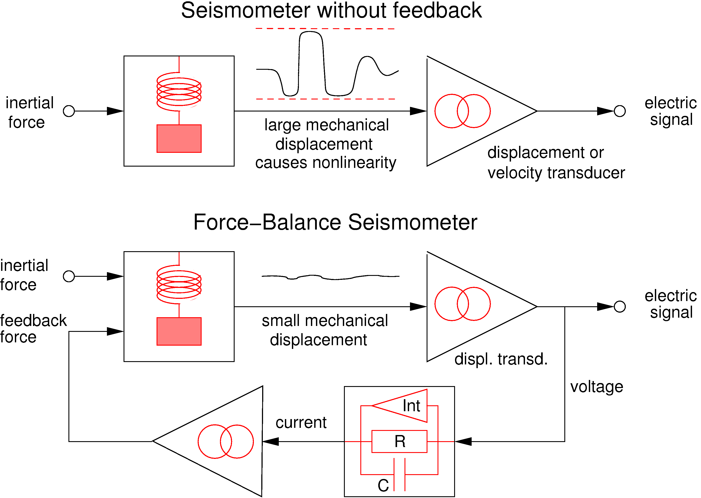

Figure 1: Block diagrams of conventional and feedback seismometers. Ideally, in the feedback configuration, the mechanical suspension and the displacement transducer “don’t see” the full amplitude of the ground motion, which is present only in the feedback path.

Brownian (thermal) noise

The resolution of an inertial seismometer is ultimately limited by the Brownian motion of its seismic mass. The energy of this motion can be concentrated near the mechanical eigenfrequency by minimizing the damping (maximizing the quality factor). Since this enhances at the same time the response to ground motion near the eigenfrequency, a high-Q suspension in fact has a reduced noise level at all frequencies when the noise is expressed as an equivalent ground motion. Treating the mechanical pendulum as a simple damped harmonic oscillator with mass M [kg], period T[s] and quality factor Q, one finds that the coefficients involved cancel approximately, and the condition for resolving minimum ground noise in the free-mode band is simply MTQ > 1 kg s. So theoretically, even a pendulum with a small mass or a small free period could be used for very-long-period recording when the quality factor is high enough. However, this is not generally true. The harmonic-oscillator model neglects the fact that the mechanical damping (especially of thermally selfcompensated spring materials) is not viscous. For a given pendulum with an adjustable period such as a LaCoste suspension, the quality factor decreases more rapidly at long eigenperiods than it should do for viscous damping. Therefore, the Brownian noise of mechanical suspensions increases at long periods, comparable to the 1/f-noise of semiconductors. Unfortunately, very few data are available on this phenomenon.

Negative Force Feedback

All modern seismic broadband sensors employ negative force feedback to keep the motion of the mass small, as illustrated in the lower half of figure 1. This helps greatly to avoid problems with mechanical imperfections of the sensor. The feedback loop sends a current through the force transducer (which is usually of the voice-coil type) that keeps the mass centered with respect to the frame. The mass then experiences the same acceleration as the ground, and the feedback current is proportional to ground acceleration. Such a circuit is also called a ‘force-balance’ system because the feedback force is supposed to balance the inertial force at all times; the same type of circuit is used in electronic laboratory balances. In VBB (velocity broadband) seismometers the feedback current charges a capacitor C, so the voltage across the latter is proportional to ground velocity. The resistor R damps the resonance that would otherwise occur at the lower corner frequency where the differential (C) and integral (Int) feedback currents cancel.

The integral-feedback path keeps the mass exactly centered in the time average, and makes the overall transfer function nearly identical to that of a conventional electromagnetic seismometer. In contrast to the resistive (proportional) and capacitive (differential) feedback paths, the integrator can only be realized with semiconductors, and adds noise to the feedback current. The dynamic range of force-balance, broadband seismometers is normally limited by the integrator. Seismometers intended to operate over a wide range of temperature, tilt, or gravity, without readjustment of the mass position need a relatively strong integral feedback whose noise limits the sensitivity at long periods. Sensitive force-balance seismometers require a mechanism for remote mass centering; they can handle low-frequency signals between about 10⁻¹¹ g (per octave) and a few times 10⁻⁴ g. The dynamic range of somewhat over 140 decibels is essentially determined by the semiconductors in the integrator. A sensor without integral feedback may have a larger dynamic range but is subject to mechanical drift and hysteresis.

The overall response (to acceleration) of a force-balance seismometer as a function of frequency is nearly inverse to the response of its feedback path, and nearly independent of the mechanical system and the displacement transducer. Thus, the linearity and stability problems of conventional seismometers are almost completely eliminated from a feedback seismometer. They are shifted to another part of the circuit, namely the feedback path, where they can be handled more easily. The responsivity (the apparent generator constant G) of a VBB seismometer in its passband is essentially determined by three passive components in the feedback path, the seismic mass, the forcer, and the feedback capacitor: G = M/σC where M [kg] is the seismic mass, σ [N/A] is the forcer constant, and C [F] the capacitance. All of these components are practically noise-free, stable, and linear over a very wide range of signals. The response of force-balance VBB sensors is therefore much more stable than that of conventional electromagnetic seismometers.

Feedback does not deteriorate the resolution of a seismic sensor when the feedback path is noise-free. It is therefore desirable that passive feedback predominates in the passband of the instrument. Seismometer designers should resist the temptation of shaping the response by introducing additional active components into the feedback path.

Digital feedback

As an example for the way in which feedback can increase the dynamic range, we may consider a system whose displacement transducer has only two output states indicating whether the mass position is “high” or “low”. A suitably designed force-balance system would nevertheless generate a feedback current that is, in the time average, proportional to ground acceleration. The seismic mass would oscillate around its equilibrium position and the feedback signal would oscillate around the value corresponding to ground acceleration. This does not necessarily disturb the seismic record provided that the oscillations have a frequency above the seismic bandwidth or an amplitude below the desired resolution. A system according to the latter condition was in 1924 used by A. De Quervain and Auguste Piccard to stabilize the mass position of a 20-ton mechanical seismograph at the Swiss Federal Institute of Technology, by adding or subtracting every minute a few drops of water from a ballast tank on top of the mass. This system came amazingly close to being a digital seismograph – had they been able to make their feedback loop some 10 000 times faster and to count the number of water drops, then their system would have been the first (and so far only) seismograph with true digital feedback.

A digital feedback circuit oscillating at high frequency is used in modern Sigma-Delta AD converters. It is also possible to design the feedback loop of a Sigma-Delta AD converter around a mechanical pendulum as the summing point, thus creating a digital seismometer. The concept of digital feedback, however, cannot be fully realized because a digitally controlled forcer with an adequate dynamic range is not available. One would have to couple an electronic DA converter to an electrostatic or electromagnetic forcer, so the feedback force would still be generated by an analog signal; the dynamic range would be limited by the DAC to something like 140 dB (7 orders of magnitude). In comparison, the combination of an electromagnetic forcer with a solid-dielectric feedback capacitor, driven by an analog circuit, produces feedback currents over a range of 240 dB or 12 orders of magnitude, say from a noise level of 10⁻¹⁴ A at 0.3 mHz to a clip level of 10⁻² A at 30 Hz. So it appears that the analog feedback loop of VBB seismometers cannot easily be replaced by a digital circuit.

Shielding

The performance of broadband seismometers at long periods depends on their thermal insulation. Most modern instruments have built-in electronics. Even if their power dissipation is low – usually below 1 W – it can create thermal convection around the sensor, and makes the sensor extremely sensitive against air drafts. To prevent this, it is recommended to wrap the instruments tightly with insulating material such as fiber wool. No air space should be left between the sensor and the insulation. Figure 2 shows how the STS2 seismometers of the German Regional Seismic Network (GRSN) are installed. The stainless-steel jacket together with the Gabbro baseplate protects the seismometer from barometric pressure fluctuations and from corrosion (the atmosphere in seismic vaults can be quite aggressive). When seismometers are operated in industrialized areas or near DC-powered railway lines, an additional magnetic shield may be required. That the insulation method used in the GRSN is efficient is demonstrated by ability to record background free oscillations of the Earth ( the “hum”), otherwise seen only at the very quietest locations worldwide, at about half of the GRSN stations.

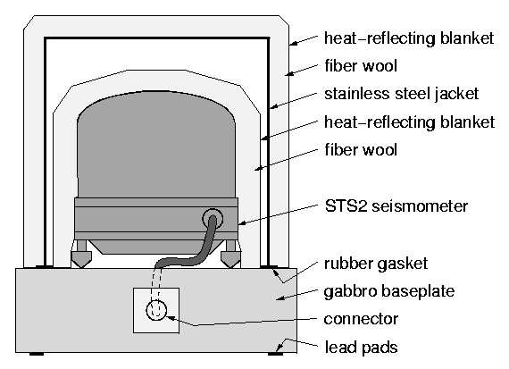

Figure 2: Shielding of the STS2 seismometers in the GRSN

A more detailed discussion of broadband seismometer design, installation, and calibration with appropriate references is found in chapter 18 of the IASPEI International Handbook of Earthquake and Engineering Seismology. The text of that chapter may also be downloaded from http://www.software-for-seismometry.de/.

