Are Hysteresis, Creep, and Damping of Mechanical Oscillators consequences of the same mechanism of internal friction?
E. Wielandt, November 2006 (e.wielandt@t-online.de)
unfinished manuscript

The internal friction of metallic alloys used for elastic springs and hinges may limit the sensitivity and precision of inertial seismic sensors, especially those not stabilized by electronic feedback. It expresses itself in different observations that seem to be unrelated at first sight:

- The purely mechanical damping of a LaCoste pendulum, when expressed as a fraction of critical damping, increases with the square of its free period, in contrast to the classical oscillator with viscous damping for which theory predicts a linear increase (G. Streckeisen 1974, our fig. 1). Since the free period of a LaCoste pendulum is adjusted by tilting the whole instrument, without any other mechanical modification, this must be a property of the spring material. Similar observations have recently been made by R. Peters (2005) with an inverted pendulum.
- The restoring force of a spring or flexural hinge decreases with the (negative) logarithm of time after a step-like deflection. This was clearly observed by E. Wielandt and J. Otero in commercial Bendix-type flexural hinges at a time scale from a few seconds to one day
(fig. 2). The creep is approximately proportional to the magnitude of the step. In Materials Science, logarithmic creep is well known. It is common in the low-temperature, low-stress regime, also in plastics, and is explained by the statistics of thermal activation of pre-existing dislocations.
- Measurements of mechanical hysteresis are insensitive to the time scale at which they are conducted. I have not investigated this myself but the general absence of timing information from experimental results conveys a clear message. Kimball and Lovell (1927) demonstrated with their ingenious rotating-cantilever method that hysteresis is the same at all frequencies from 0.03 to 50 Hz. Their results are commonly attributed to internal solid friction.

We show here that observations 1 and 3 are mathematical consequences of the logarithmic creep law 2 as long as the principle of superposition holds. What this means for the actual physical mechanism is not clear since alternative explanations exist.

Definition of the problem
We have studied creep as a change in restoring force versus time. In the type of experiments we have made, using astatic suspensions, the creep must be considered independent of the absolute magnitude of the restoring force because the latter can be adjusted or eliminated by tilting a LaCoste spring pendulum, or raising the centre of gravity of a simple pendulum above the axis of rotation. These adjustments have no effect on the elastic members of the pendulum and thus on force creep (relaxation). However, they affect the definition of the quality factor Q of astatic suspensions, as will be discussed later.

Observation 2 suggests describing the creep of the restoring force after a step x₀ in the deflection as
(1) $f(t)=γx_{0} H(t−t_{0}) \text{log}\frac{t−t_{0}}{τ}$
where γ is a stiffness (usually a small fraction of the stiffness of the elastic members), t₀ is the time where the step occurs, and τ is a time constant that serves only to make the argument of the logarithm dimensionless. Its choice is irrelevant except that we must define the spring stiffness S as the ratio of force to deflection measured at time t = t₀ + τ .

The trend of the force f (t) is opposite to the elastic restoring force –S x₀ that is due to the stiffness S of the elastic member. It has the same direction as the deflection x₀ and will increase the deflection in experiments where the pendulum is deflected with an external constant force. Here, however, we apply a constant deflection and observe the force necessary to maintain it. The magnitude of this (negative) force decreases with time, a process called relaxation. So f (t) describes the relaxation of the elastic force of the spring or hinge.

We unfortunately did not pay enough attention to the problem of amplitude linearity in our experiment. Does one-third of the input amplitude actually produce one-third of the creep? Roughly this appeared to be so, but we did not try a large range of amplitudes, and in retrospect find some inconsistency in our data, as if something undocumented had happened to our apparatus between two series of measurements. The recorded waveforms are fine, but the amplitudes need further study.

The representation of the step response by eq. (1) is problematic in the limits of short and long times after the step; in both cases the hysteretic force tends to infinity. The singularity at short times disappears when the source function is continuous, and is thus no more “unphysical” than assuming a discontinuous deflection. Some authors have nevertheless preferred to use a modified creep law of the form $\text{log}(1+(t−t_{0})/τ)$ with a small τ (e.g. Lomnitz 1957a), thus removing the singularity at t=t₀ but otherwise complicating the mathematical treatment.

At long periods our mathematical approach is formally unphysical: the force would creep indefinitely, without an asymptotic limit, in response to a permanent deflection, and would eventually change its sign. Practically, however, we need not care because the unphysical behaviour would manifest itself only after an astronomical time span. Other simple creep laws are even more unphysical in this respect. A mathematical consequence is that the creep function cannot be treated with the Fourier transformation, or convolved with pure sinewaves in time domain. The Fourier and convolution integrals don’t converge at infinity. This difficulty is circumvented by using the Laplace transformation, which implies an exponential taper. We note here, without proof, that any other reasonable taper would give the same result. Applying a taper is physically justified because pure sinewaves are a mathematical idealization; practically we can only use only sinewaves of finite duration.

Eq. (1) presents still another problem: if it describes the step response, then it should not at the same time describe the response to a square wave, i.e. periodically repeated steps of alternating sign. We find, however, that the response to square waves is very well modelled by eq. (1) – compare fig. 2. The expected difference is not very large, and may have been masked by other experimental effects or by the fitting procedure. It is also conceivable that a sudden deformation or vibration partially erases the memory of what happened earlier. This would be a nonlinear behaviour, which we do not try to model here although it may be quite noticeable in reality, even at low stress.

Since in (1) we have defined the step response of our system, it will be convenient to represent an arbitrary input signal (i.e. deflection of the pendulum) as a sum or an integral over step functions. Using the symbol H(t) for the unit-step (Heaviside) function, we can write
(2) $x(t)=\int_{−∞}^{t}{ \overset{˙}{x}(ϑ)H(t−ϑ)dϑ}$
(Proof: under the integral,$t−ϑ$ is non-negative, thus$H(t−ϑ)=1$, and the integration is trivial; we assume $x(−∞)=0$.)

Response to a ramp
Let us now consider a forced deflection with the waveform of a ramp, rising from zero at time t₁ to x₀ at time t₂ and being constant afterwards. The time derivative $\overset{˙}{x}(t)$ has the constant value x₀ / (t₂-t₁) between t = t₁ and t = t₂, and is zero elsewhere. Thus according to (2):
(3) $x(t)=\frac{x_{0}}{t_{2}−t_{1}} \int_{t_{1}}^{t_{2}}{ H(t−ϑ) dϑ}$
If the principle of superposition holds, the force response is
(4) $f(t)=\frac{γ x_{0}}{t_{2}−t_{1}} \int_{t_{1}}^{t_{2}}{H(t−ϑ) \text{log}\frac{t−ϑ}{τ}dϑ}$
(5) $f(t)=H(t−t_{1}) γ x_{0}\frac{t−t_{1}}{t_{2}−t_{1}} ( \text{log}\frac{t−t_{1}}{τ}−1)−H(t−t_{2}) γ x_{0}\frac{t−t_{2}}{t_{2}−t_{1}} ( \text{log}\frac{t−t_{2}}{τ}−1)$
Since $t \text{log}(t)⇒0$ for $t⇒0$, the response is continuous at t₁ and t₂. The time derivative $\overset{˙}{f}(t)$is discontinuous but bounded. Figure 3 shows an example. Shortly after the end of the ramp, the creep can be approximated by a single logarithmic curve (green). The response is then nearly the same as that to a step at the median time of the ramp. Since any mechanical input can be approximated by a sequence of ramps, eq. (1) predicts finite creep rates for all physically realizable inputs.

Response to a sinewave
In order to relate eq. (1) to intrinsic damping, we consider a sinusoidal deflection:

(6) $x(t)=x_{0} \text{cos}ω t$
$\overset{˙}{x}(t)=−x_{0} ω \text{sin}ω t$
In Laplace notation we represent x(t) as the real part of
(7) $\tilde{x}(t)=x_{0}\text{exp}(st)$
where s = σ + jω with σ > 0 ; later the limit $σ→0$will be taken. For simplicity we treat our pendulum (seismometer) as one with a linear motion of the mass although most practical long-period seismometers are rotational pendulums. According to (2),
(8) $\tilde{x}(t)=x_{0 }s\int_{−∞}^{ t}{ \text{exp}(s ϑ) H(t−ϑ) dϑ}$
Again assuming linear superposition, the force response to this deflection is
(9) $\tilde{f}(t)=x_{0} s γ\int_{−∞}^{ t}{\text{exp}( μ\text{}sϑ) \text{log}\frac{t−ϑ}{τ}} dϑ$
We substitute $\frac{t−ϑ}{τ}=t^{'}$:
(10) $\tilde{f}(t)=x_{0} s γ τ \text{exp}(s t) \int_{0}^{∞}{{ \text{exp}(−sτt^{'}) \text{log \{}t}^{'}} dt^{'}$
According to Gradstein and Ryshik (1981), integral 4.331 with μ = sτ, this gives
(11) $\tilde{f}(t)=−x_{0} γ(C+\text{log} sτ)\text{exp}(st)$
where C = 0.577215.. is Euler’s constant. We can now reinsert s = σ + jω, take the limit $σ→0$, and omit the imaginary part of $\tilde{f}(t)$. Note that the logarithm of sτ = jωτ has an imaginary part of π/2, which combines with the imaginary sine of the exponential function.

(12) $f(t)=−x_{0}γ(C+\text{log}\text{ωτ}) \text{cos}ωt+x_{0}γ\frac{π}{2}\text{sin}ωt$
This is our main result. The creep force has a cosine component that is opposite to the deflection, and makes the effective restoring force slightly frequency-dependent. The elastic members become stiffer at higher frequencies. The sine component is opposite to the velocity of the deflection (compare eq. 6) and thus represents a form of damping. It does, however, not correspond to either one of the most commonly assumed mechanisms of damping: solid friction and viscous friction. Solid friction is independent of the frequency and of the amplitude of motion. Viscous friction is proportional to the velocity of motion, thus to both the frequency and the amplitude. The magnitude of the sine term is proportional to the amplitude but not to frequency. According to Kimball and Lovell (1927), this behaviour is typical for the internal friction of a wide variety of materials, including metals, glass, rubber and even wood.

Logarithmic creep and hysteresis
We now consider the energy loss in one cycle of the oscillation. It can be calculated as the integral of velocity times opposing force, thus
(13) $ΔE=x_{0}^{2}\text{ωγ}\frac{π}{2}\int_{0}^{ 2π/ω}{ {\text{sin}}^{2}ω t^{'}dt^{'}}=x_{0}^{2}\text{ωγ}\frac{π}{2}\frac{T}{2}=\frac{1}{2}π^{2}x_{0}^{2}γ$
The cosine term in (12) does not contribute to the energy loss. ΔE is independent of frequency, a feature normally associated with solid friction. The logarithmic creep law explains the same behaviour without introducing a nonlinearity. It also predicts that hysteresis in the classical sense is independent of the time it takes to drive the specimen through a stress cycle. More directly, eq. (12) states that force hysteresis is independent of the cycling time. This does however not imply that logarithmic creep alone is responsible for hysteresis. To the contrary, it appears that hysteresis is mainly due to internal solid friction, and logarithmic creep makes only a minor (although noticeable) contribution to hysteresis. (We need not speculate about this: internal friction is instantaneous but creep is a function of time, so they can be experimentally distinguished.) Internal solid friction appears to be more difficult to understand than logarithmic creep. It would be linear (that is, compatible with the superposition principle) only under somewhat artificial assumptions; most probably, it is not a linear phenomenon. I speculate that the relative importance of solid friction may decrease at small amplitudes so that internal friction is asymptotically dominated by creep, and then linear. Direct measurements of hysteresis are usually made at relatively large stress amplitudes, so we may not learn much from these about the small-amplitude limit.

Logarithmic creep and the quality factor
We finally calculate the quality factor of the free oscillation of the pendulum. Its maximum kinetic energy, and thus the total energy of the oscillation, is $E={Mω}_{0}^{2}x_{0}^{2}/2$where M is the mass and $ω_{0}$ the eigenfrequency. The quality factor is

(14) $Q=\frac{2 π E}{ΔE}=\frac{2 M ω_{0}^{2}}{π γ}=\frac{8 π M}{γ T_{0}^{2}}$
Q increases with the square of the eigenfrequency, and $Q^{−1}$with the square of the free period T₀, as observed by Streckeisen (1974). As in the case of hysteresis, the concept of internal solid friction predicts the same for a given amplitude of the oscillation, but cannot easily explain why Q is apparently constant over a considerable range of amplitudes.

A closer look at the definition of the quality factor Q
Assuming a logarithmic creep function, Lomnitz (1957a,b) concludes that this law leads to “approximate constancy, over a considerable range of frequencies, of the internal friction $Q^{−1}={ΔE}/2πE$”. This seems to be at odds with our result – but it only seems so. In fact the definition of Q, although formally the same, has different consequences in wave propagation and in seismometry. In wave propagation, W is the maximum elastic energy of a propagating sinusoidal wave, and ΔW the energy lost in one cycle (both quantities to be measured in a small volume of the elastic medium). Energy is converted between elastic and kinetic; gravitational energy is normally ignored. A seismometer pendulum, however, has potential energy in the gravitational field, and during its oscillation converts elastic energy into gravitational energy and vice versa. In an astatic pendulum most of the energy oscillates between elastic and gravitational, and only a small fraction between elastic and kinetic. Only the latter determines the frequency of oscillation and enters into the determination of Q. The kinetic energy is proportional to the square of the eigenfrequency. So while for wave propagation and related phenomena the logarithmic creep law predicts a constant quality factor, the same law predicts a quality factor proportional to the square of the eigenfrequency for an astatic pendulum with an adjustable period. This was also noticed by Peters (2004).

Creep and the thermal activation of dislocations
Logarithmic creep can be explained with exhaustion theory. The theory of creep goes back to Boltzmann (1874, 1878); exhaustion theory was formulated by Mott and Nabarro (1948) and others. It is concisely characterized by Davis and Thompson (1950) as “a theory of transient creep in metals based on the idea of the gradual exhaustion of a supply of dislocations already present in the metal crystal at the beginning of the test”. For a more recent discussion see Cottrell (1997); he concludes that “the original form of the exhaustion theory may be applicable in materials hardened by larger-scale obstacles, as in precipitation hardening”. Alloys of this type are used for seismograph springs and hinges. What follows is my private version of exhaustion theory.

An elastic body may be modelled as an assembly of a large number of elastic elements in a three-dimensional matrix in which the elements are connected both “in series” and “in parallel” so that the overall elastic behaviour is an average over the behaviour of the individual elements. Some of the elements may follow a purely elastic stress-strain law; others may exhibit hysteresis as we now define it. We assume that the stress in these elements disappears spontaneously when a blocked dislocation happens to be thermally activated. The average stress of the elastic body is then diminished by some small amount. We denote an element that has not yet been activated as “charged” and one that was activated as “discharged”. The discharge occurs when the thermal energy of a specific atom or a group of atoms blocking the dislocation exceeds a given activation level typical for the element. We assume that the activation energies of the elements are uniformly distributed so that an equal number of elements are found in equal intervals of the activation energy. Of course this distribution is only required at energies that actually occur with a non-vanishing probability. In all other respects, the elements may be assumed to be equal, although this is not an essential condition. It is likewise not essential that the stored stress is completely released upon activation. We require only that the activation energy is independent of the stress and the average stress release is proportional to the existing stress.

According to Boltzmann statistics, the distribution of gas molecules between different levels of kinetic (thermal) energy E follows exp(-E/kT) where k is the Boltzmann constant and T the absolute temperature. The same factor also determines the relative number of molecules with an energy greater than E. We generalize this concept by postulating that in a given time interval, the probability for a element being thermally activated is proportional to exp(-βE) where E is its activation energy and β a scaling factor. So of all elements having activation energies between E and E+ΔE, a fraction proportional to exp (-βE) will be discharged; the rest remains stressed and waits for another chance. Elements with low activation energy are quickly discharged and provide a high initial creep rate. Later, only elements with increasingly higher activation energies remain, and discharge more rarely because they are activated with a smaller probability. So the creep rate must diminish with time. It is straightforward and easy to simulate this process numerically. The result is that as soon as most of the elements with the lowest activation energy have been discharged, the creep rate adjusts itself to being proportional to 1/t, and the creep itself is proportional to log t as formulated in eq. (1). We now give a mathematical derivation of this result.

We subdivide the range of activation energies into bands of equal width, $n ΔE≤E<(n+1) ΔE$ for band number n. We choose the units of energy and time so that the probability of thermal activation within one unit of time for the n-th band is

(15) $P(n)=ε \text{exp}(−βn)$
where ε and β are small positive numbers. If there are N elements in every energy band, all of which start in the charged state, then after one unit of time $Nε \text{exp}(−βn)$elements will have been discharged and the remaining $N(1−ε \text{exp}(−βn))$are still charged. At time t, the number of charged elements in the n-th band is

(16) $S(n,t)=N(1−ε \text{exp}(−βn)) ^{t}$

We now look at the population profile S(n,t) as a function of n for fixed t: how many charged elements survive to time t in each band? It turns out that after a time t₀ at which nearly all elements with the lowest activation levels have been discharged, the population profile approaches an asymptotic sigmoidal shape that is then only shifted towards higher energies as time increases. The mathematical condition for this is: for each time t > t₀ there exists a Δn such that

(17) $S(n,t)=S(n−Δn,t_{0})$
for all n. Inserting (2) we have
(18) $N (1−ε\text{exp}(−β n))^{t}=N (1−ε\text{exp}(−β n+β Δn))^{t_{0}}$
Cancelling N and taking the logarithm of both sides:
(19) $t \text{log}(1−ε\text{exp}(−β n))=t_{0}\text{log}(1−ε\text{exp}(−β n+β Δn))$
Since $ε\text{exp}(−β n)$is small (the energy bands with low n where this is questionable have already been depleted), we can use the approximation $\text{log}(1+x)≈x$to obtain

(20) $t \text{exp}(−β n))=t_{0}\text{exp}(−β n+β Δn))$
and finally
(21) $\text{log}t=\text{log}t_{0}+β Δn$
So we find that Δn is indeed independent of n, and condition (17) is satisfied whenever $ε\text{exp}(−β n)$ is small for all energy bands not yet depleted. By going backward through this calculation, we obtain an explicit formula for the asymptotic population profile:

(22) $S(n,t)≃N\text{exp}(−\text{exp}(−βn+\text{log}ε+\text{log}t))$
The exact form (16) and the asymptotic form (22) are compared in fig. 4; they agree very well.

Equations (21) and (22) as well as figure 4 show that the number of energy bands by which the population profile has been shifted increases with the logarithm of time. A shift by one band implies the discharge of exactly N elements, distributed over many bands. Each discharge of N elements will reduce the total stress in the elastic member by the same amount, a certain percentage of the originally applied stress. Thus, in our simple model, the creep is proportional to log t and proportional to the applied stress, as expressed by eq. (1). It is clear that this simple relationship can hold only for small stresses and deformations. Large stresses will modify the activation energies to such an extent that our simple model is no longer applicable.

The model also provides a natural solution to the problem of unlimited creep: in reality there is only a finite number of elements that can be activated, so the creep has a natural limit. Other deviations from the logarithmic creep law can likewise be modelled without major conceptual changes, by assuming a non-uniform distribution of the activation energies.

References
Boltzmann, L., 1874. Zur Theorie der elastischen Nachwirkung. Wien. Ber. 70, 275-306 and
Pogg. Ann. Erg. Bd. 7, 1876, p. 624 ff.
Boltzmann, L., 1878. Zur Theorie der elastischen Nachwirkung. Wied. Ann. 5, 430-432.
Cottrell, A. H., 1997. Logarithmic and Andrade creep. Phil. Mag. Letters 75 No. 5, 301-307.
Davis, M. and Thompson, N., 1950. Creep in a Precipitation-Hardened Alloy.
Proc. Phys. Soc. B 63, 847-860.
Gradstein, I. S. and Ryshik, I. M., 1981. Tables of series, products and integrals. Verlag Harri
Deutsch, Thun and Frankfurt am Main.
Kimball, A. L. and Lovell, D. E., 1927. Internal friction in solids. Phys. Rev. 30, 948-960.
Lomnitz, C., 1957a. Linear dissipation in solids, J. Appl.Phys. 28, 201-205.
Lomnitz, C., 1957b. Application of the logarithmic creep law to stress wave attenuation in the
solid earth. J. Geophys. Res. 67 No. 1, 365-368.
Mott, N. F. and Nabarro, F. R. N., 1948. Rep. Bristol Conf. Strength of Solids, p. 1. Physical
Society, London.
Peters, R., 2004. Friction at the mesoscale. Contemporary Physics 45 No. 6, 475-490.
Peters, R., 2005. Nonlinear damping of the “linear” pendulum.
http://arxiv.org/ftp/physics/papers/0306/0306081.pdf, figure 4.
Streckeisen, G., 1974. Untersuchungen zur Messgenauigkeit langperiodischer Seismometer,
Diplomarbeit, Institut für Geophysik der ETH Zürich
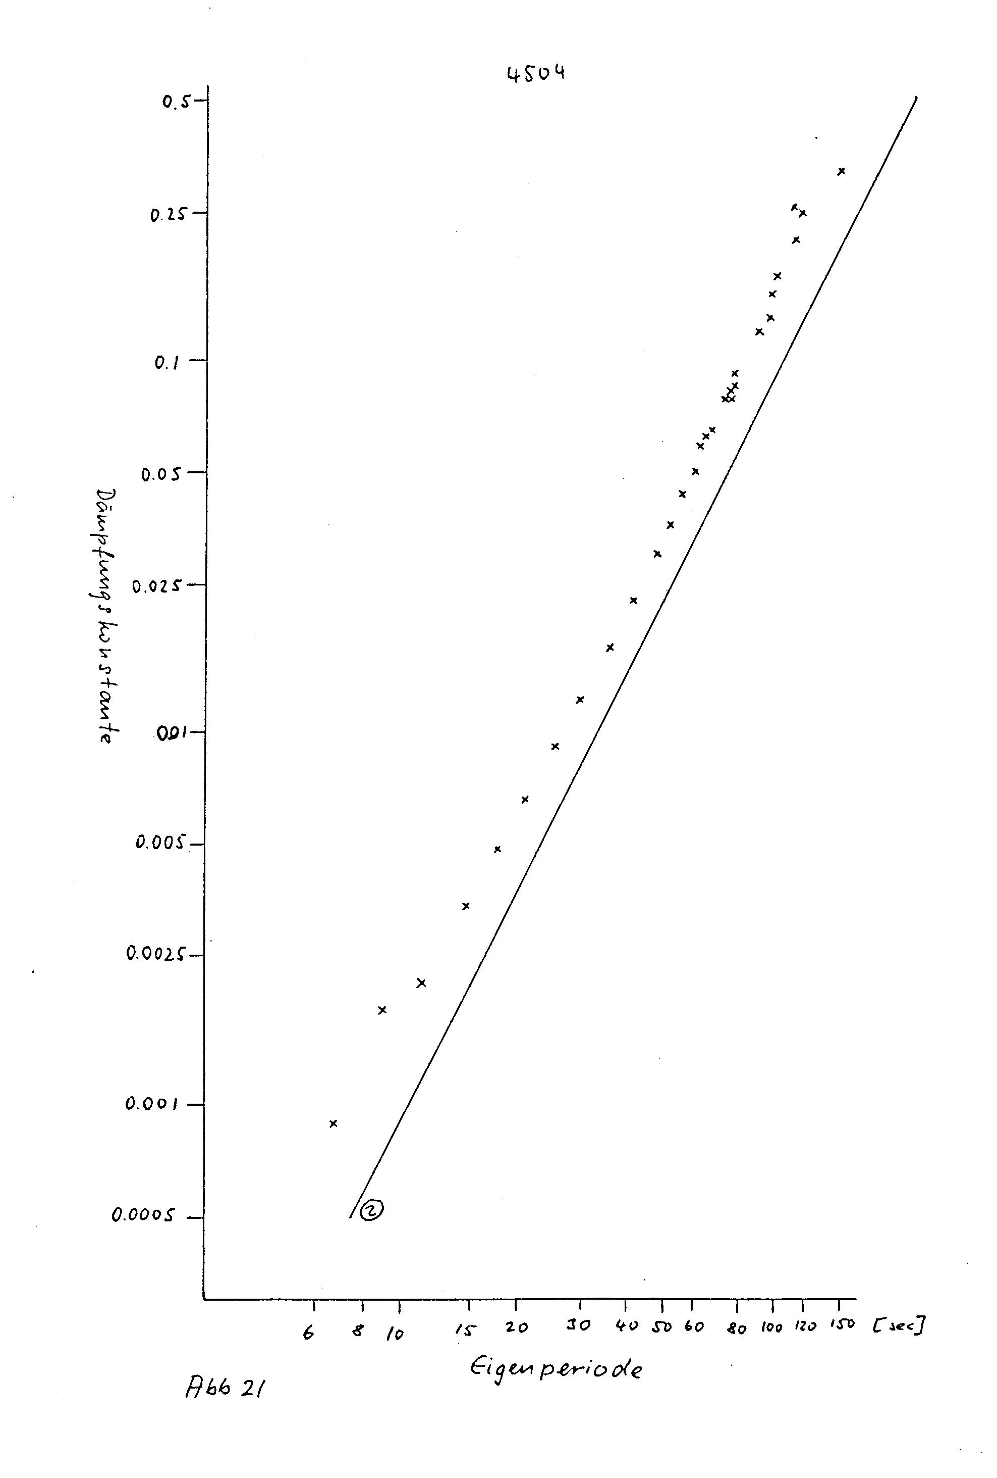

Figure 1: Intrinsic mechanical damping (as a fraction of critical damping) of a LaCoste type long-period vertical seismometer versus the mechanical free period. From Streckeisen (1974). The seismometer was a Sprengnether vertical electromagnetic long-period seismometer type S-5100V, serial number 4504. The magnets of the seismometer were removed for this experiment because they produced considerable air damping. The slope of the line (2) indicates proportionality to T₀ ².
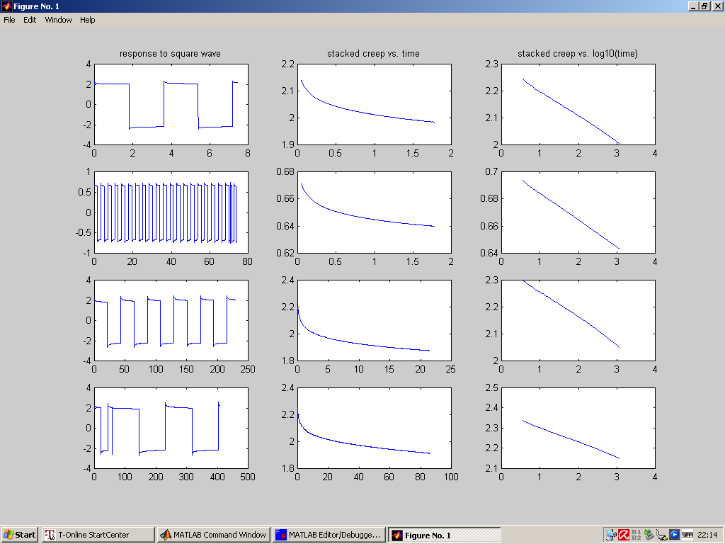

Figure 2: Creep (relaxation) of a balanced pendulum (a “non-seismometer”) that was built to study hinge hysteresis separate from the imperfections of a main spring or seismic noise. Its design is similar to that of a prototype “optical” seismometer (see http://gravity.ucsd.edu/research/SIFO/) but it has no leaf spring and has balanced masses on both sides of the axis. The pendulum has a simple optical displacement transducer and electromagnetic force feedback that keeps the transducer centered. By displacing the normally fixed part of the transducer on a linear stage, we can deflect the pendulum and measure the time-dependent force necessary to hold the pendulum in the new position.

The figure shows data from four experiments. Left: original records. Time is in units of 1000 s. Centre: stacked creep signals; the negative amplitudes have been inverted. Time in units of 1000 s. Right: same plotted against log10(t), t in seconds; these plots show only the first half hour of the response, after which time small deviations from the logarithmic creep law become noticeable. From top to bottom: the half-periods of the square waves were 0.5, 0.5, 6 and 24 hours. The second row is an experiment with a deflection of ±1 mm at 70 mm from the hinge while in the other experiments the deflection was ±3 mm. The creep appears amplified about 10 times relative to the static moment because the restoring moment of the hinges was partially compensated by the geometry of the pendulum. So the total creep was actually about 1% of the static moment, or 0.5% of its peak-to-peak amplitude, not 10% resp. 5% as the figures might suggest.
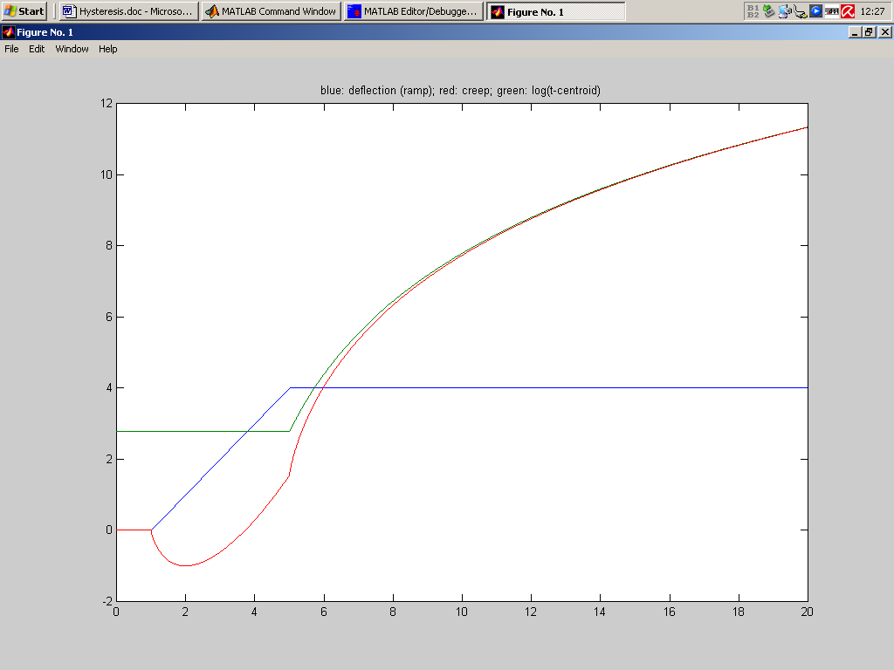

Figure3: An example for the theoretical creep response (red) to a ramp-like deflection (blue). The green curve represents, after the end of the ramp, the response to a step at the median time of the ramp. The time scale is meant to be in seconds but is actually irrelevant since the same waveform would be observed in any other time scale. The figure illustrates that despite the description of the step response by the log(t) function, the response to a continuous input is continuous.
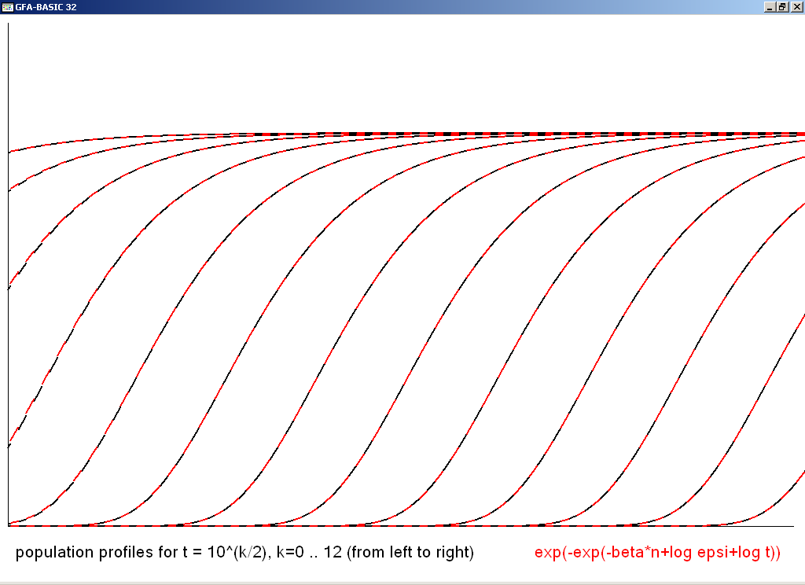

Fig. 4: Population profiles of our creep model at different times. Activation energies increase along the horizontal axis; the vertical axis represents the number of undischarged elements per energy band (zero at the bottom and N at the top). The black segments of the curves have been calculated from formula (17) and the red ones from formula (23). No difference between the two versions is visible when the elements with the lowest activation energies have been discharged, in this example for t≥100.

